Tranfer Wizard
The transfer wizard is usful for moving items or call numbers from one title to another, if they have been created on the wrong title or if there is requests for consolidation of titles to one central title. By using the transfer wizard, the item retains all it’s item information, including its barcode and all its circulation stats, instead of having to be deleted and re-added.
To transfer and item, first, find the title you want to transfer your item to, using item search and examining the Records and Description to be sure you have the correct title. Once you do, click the “Add to Tree” button. The title will appear in the middle box of the wizard:
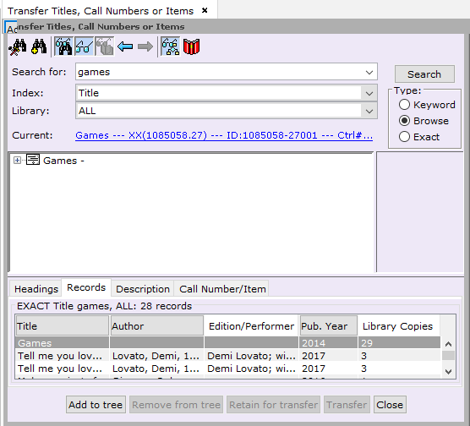

Next, find the item you want moved to the other title. Click “Add to Tree” again.
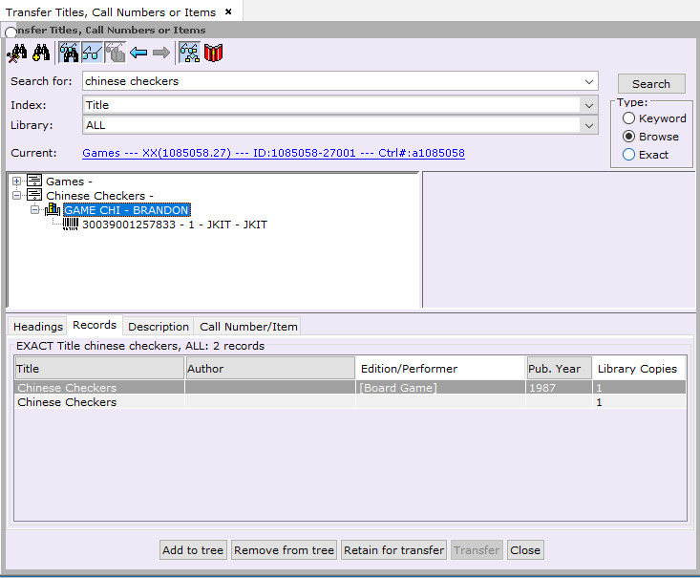

Highlight the call number of the item you want transferred, and click “Retain for Transfer”. The call number and item will turn bold and italic:
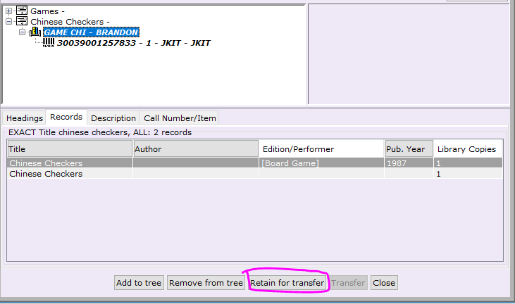

Move up to the top title, the title you want to transfer your item to. With the title highlighted, click the “Transfer” button:
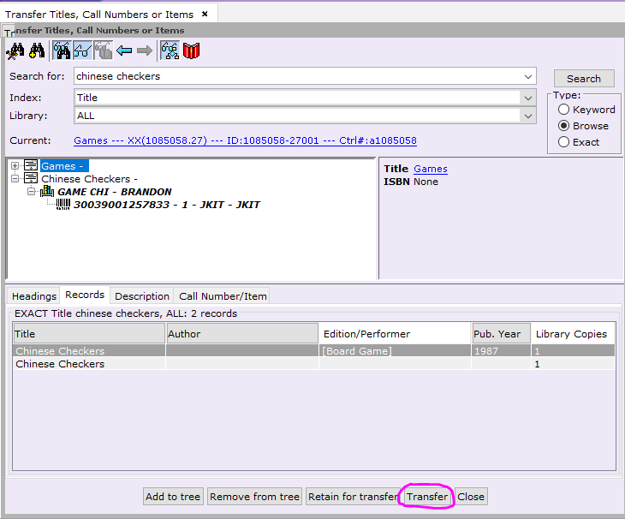

If the item being moved is the only item on the record, you will be prompted to delete the title record: click “Yes”.

After the item is transferred or the transfer is canceled, a results box will pop up, with the details of what occurred:
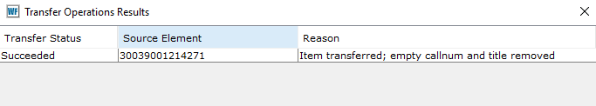
Click “OK” at the bottom.
Continue adding titles to the tree and transferring items until done. If an item is transferred that does not remove the title it came from, the title can be dismissed by clicking “Remove from tree” to remove it from the transfer wizard’s middle box, to keep from inadvertently moving the an item to it.

